Internal Proposal Evaluation

Detailed Design Document

-MGMS Ver. 1.6-

Version History
Date | Description
10-Jan-2010 | First Draft

Table of Contents

Version History 2
1 Introduction 5
2 Internal Proposal Evaluation 5
2.1 Initial Administrative Functions 5
2.1.1 Adding new users - reviewers: 5
2.1.2 Creating approval Authorities: 5
2.1.3 Upload Pre-proposal Application form 8
2.1.4 Add Proposal Category 9
2.2 Submission of Pre-proposal by staff members 10
2.3 Proposal Authority Mapping 13
2.4 Pre – proposal Review 14
2.5 Submission of Full proposals by staff members 19
3 Associated Tables 21
4 Data Dictionary 23

Table of Figures

Figure 1: Add approval authority 6
Figure 2: Admin - Add members to approval authority 7
Figure 3: Admin - Edit approval authority 8
Figure 4: Admin - upload pre-proposal application 9
Figure 5: Admin – Add Proposal Category 9
Figure 6: Staff – Add new proposal 10
Figure 7: Staff - Application form 11
Figure 8: Staff - Save/submit pre-proposal 11
Figure 9: Staff - Pre proposal List 12
Figure 10: Staff - Pre proposal review status 12
Figure 11: Admin - Assign proposal to Approval Authority 13
Figure 12: Admin – Edit proposal-approval authority map 14
Figure 13: Reviewer – Pre proposal List 15
Figure 14: Reviewer – Pre proposal details 16
Figure 15: Reviewer - Pre proposal status 17
Figure 16: Reviewer - Pre proposal - view past reviews 17
Figure 17: Staff - Pre proposal status tracking 18
Figure 18: Staff - Pre proposal review status 18
Figure 19: Staff – Full proposal List 19
Figure 20: Staff – Full proposal upload 19
Figure 21: Staff – Full Proposal List – Status 20
Figure 22: Staff - Full proposal Review Status details 21
Figure 23: Reviewer - Full Proposal - View past reviews 21

Introduction

This document provides the detailed functional specifications for the various activities associated with proposal evaluation within an organization using the Multisite Grant Management System application.

This is a ‘living document’ and the specification will change, continuously, as the project proceeds. More details will be added and the existing information edited as the requirements, architecture and design evolve in the course of the project.

Internal Proposal Evaluation

Initial Administrative Functions

Adding new users - reviewers:
A new role “Reviewer” has been added to GMS. The reviewers can be added by the Administrator through Add User page and the role can also be assigned here.

Creating approval Authorities:
On the left menu panel, the administrator clicks on Approval Authority menu. It expands to display the sub menu – Add Approval Authority.

On clicking Add Approval Authority, the page below opens up. Here each group of approving persons at the institution is registered. Further, for each approval authority, the members are also added.

Figure 1: Add approval authority
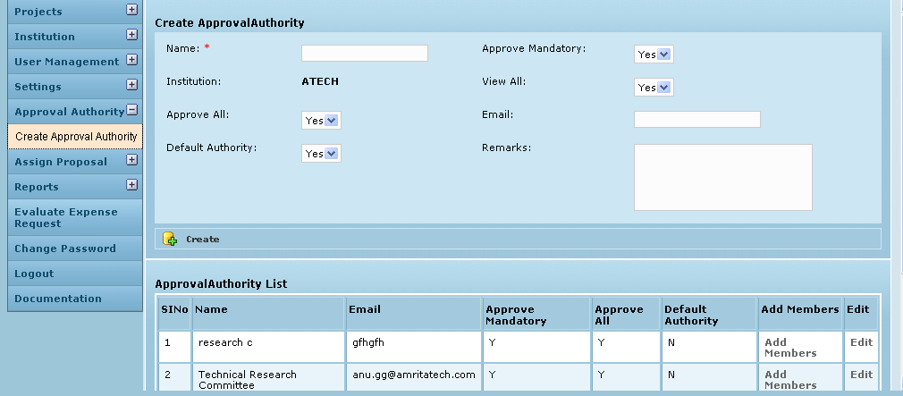

Field /Label | Input-Control |  | Data Type | Details
Add/Edit Approval Authority
Name |  | Textbox | Varchar(255) | approval_authority>name
Email |  | Textbox | Varchar(255) | approval_authority>email
Party |  | Drop down List box | Varchar(255) | party>code
Approve Level |  | Textbox | Varchar(255) | approval_authority>approve_level
Approve All |  | Drop down List box | Char(1) | approval_authority>approve_all
Approve Mandatory |  | Drop down List box | Char(1) | approval_authority>approve_mandatory
View All |  | Drop down List box | Char(1) | approval_authority>view_all
Remarks |  | Textbox | Varchar(255) | approval_authority>remarks
Active |  | Drop down List box | Char(1) | approval_authority>active_yes_no
Default |  | Drop down List box | Char(1) | approval_authority>default_yes_no
Create |  | Button
Approval Authority List
ID |  | Auto increment
Name |  | Auto populated |  | approval_authority>name
Email |  | Auto populated |  | approval_authority>email
Approve Level |  | Auto populated |  | approval_authority>approve_level
Approve Mandatory |  | Auto populated |  | approval_authority>approve_mandatory
Approve all |  | Auto populated |  | approval_authority>approve_all
Add members |  | Link |  | Opens the page (Fig 3)where specific members are added from the Reviewer list.
Edit |  | Link |  | Opens page to edit the details captured here.

The fields bordered in red are mandatory.
The personal details are: Name of the group, group e-mail ID and Institution. Further, the Approve Mandatory field decides if the particular group’s approval is mandatory and it is set to “Y” (Yes) by default. View All is set to “Y” (Yes) by default which indicates that the members of this group are privileged to view all proposals even if they don’t get to review them. Setting a group inactive here will result in removing the group from all user options. It is then deemed to be non-existing.
In the Approval Authority List, for each line item (approval authority) , clicking on Add Members opens the page below, where members can be added to/removed from each Approval authority. The existing reviewers are displayed in the table on the right (faculty) from which selection can be made.
Figure 2: Admin - Add members to approval authority
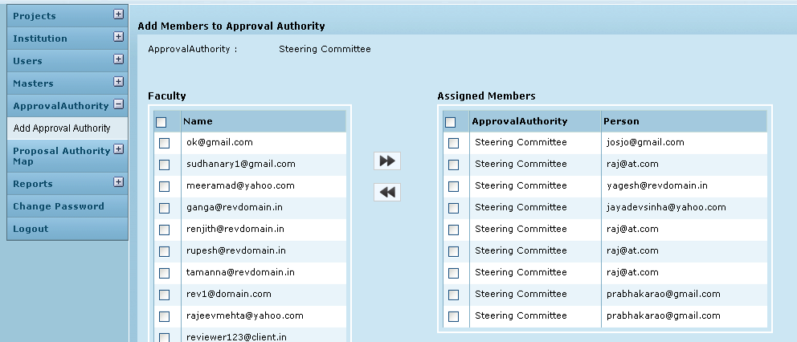

Field /Label | Input-Control |  | Data Type | Details
Add members to approval authority
Approval Authority |  | <approval authority name> | Varchar(255) | approval_authority>name
Reviewer
Name |  | <reviewer name> | Varchar(255) | all users of the institution
 |  | select check box |  | person>username
Assigned Members
Approval Authority
Person |  | <selected reviewer name> | Varchar(255) | person>username
 |  | select check box

In the Approval Authority List (Fig 4), for each line item (approval authority), clicking on Edit, opens the page below, where any modification can be made.

Figure 3: Admin - Edit approval authority
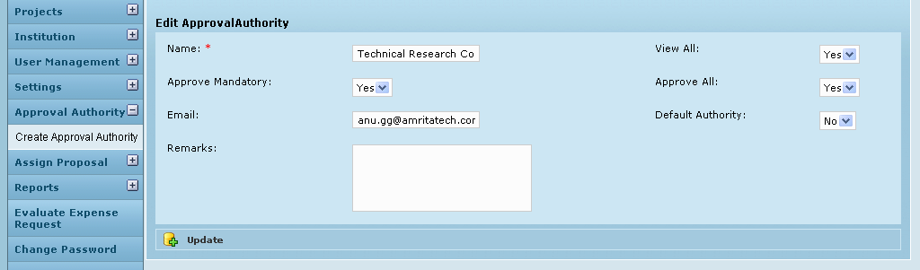

Field /Label |  | Input-Control | Data Type | DB Table>field
Edit Approval Authority
Name | Auto populated but editable Textbox |  | Varchar(255) | approval_authority>name
Email | Auto populated but editable Textbox |  | Varchar(255) | approval_authority>email
Party | Auto populated but editable |  | Varchar(255) | party>code
Approve Level | Auto populated but editable |  | Varchar(255) | approval_authority>approve_level
Approve All | Auto populated but editable |  | Char(1) | approval_authority>approve_all
Approve Mandatory | Auto populated but editable |  | Char(1) | approval_authority>approve_mandatory
View All | Auto populated but editable |  | Char(1) | approval_authority>view_all
Remarks | Text area auto populated |  | Varchar(255) | approval_authority>remarks
Default | Auto populated but editable |  | Char(1) | approval_authority>active_yes_no
Update | Button |  |  | approval_authority>default_yes_no

Upload Pre-proposal Application form
The admin logs in the system and on the left menu panel, clicks Proposal Authority map. When the menu expands, the admin clicks on Upload Proposal Form to open the screen shown below. Here, the admin can browse and upload the form used by the institution to capture details of the proposal which constitutes the pre-proposal.

Figure 4: Admin - upload pre-proposal application
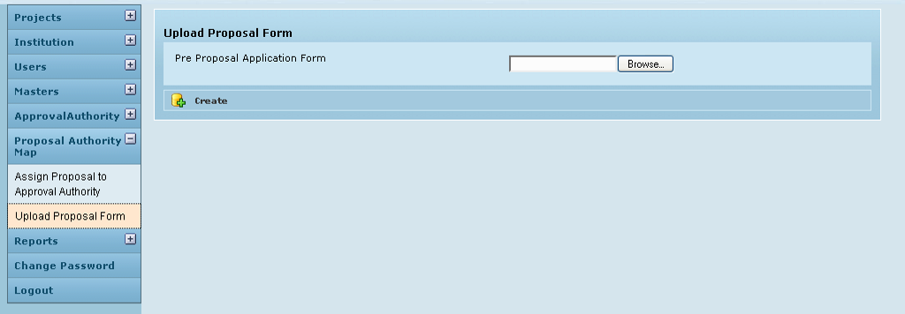
Field /Label | Input-Control |  | Data Type | Details
Upload Proposal Form
Pre proposal application form |  | Textbox, “Browse” button | Varchar(255) | pre_proposal>pre_proposal_form
Create |  | button

Add Proposal Category
The Admin has to save the various proposal categories in the GMS application for users (staff) to select from while creating their proposals. Examples for category are Research, e-content, infrastructure, network etc. This is done in the Masters module, sub menu – Proposal Category

Figure 5: Admin – Add Proposal Category
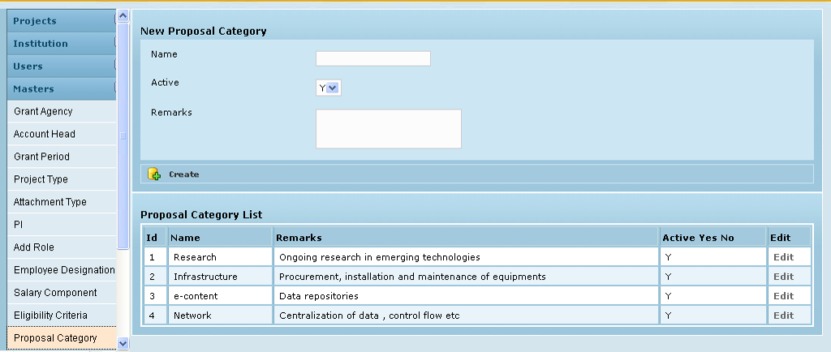
Field /Label | Input-Control | Data Type | Details
New Proposal Category
Name | Textbox | Varchar(255) | proposal_category>name
Active | Listbox | Varchar(255) | proposal_category>active_yes_no
Remarks | Text area | Varchar(255) | proposal_category>remarks
Create | Button
Proposal Category List
ID | Auto increment
Name | Auto populated |  | proposal_category>name
Remarks | Auto populated |  | proposal_category>remarks
Active | Auto populated |  | proposal_category>active_yes_no
Edit | Link |  | Opens Edit page to modify the details here

Submission of Pre-proposal by staff members
The staff includes those users who submit pre-proposals /proposals for evaluation. The Staff logs into the application to create and submit pre-proposals to own institution for review. After logging in, user clicks Pre proposal Menu on the left panel and then clicks Add New Proposal. The page below is opened.
Figure 6: Staff – Add new proposal
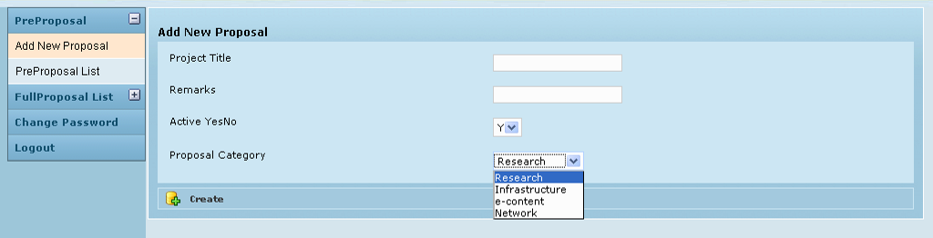
Field /Label | Input-Control | Data Type | Details
Add New Proposal
Project Title | Textbox | Varchar(255) | pre_proposal>project_title
Remarks | Textbox | Varchar(255) | pre_proposal>remarks
Active Yes No | List box | Char(1) | pre_proposal>active_yes_no
Proposal Category | List box | Varchar(255) | proposal_category>name
Create | Button

On clicking Create, the institution’s pre-proposal application form is opened for the Staff to fill up the pre-proposal details:
Figure 7: Staff - Application form
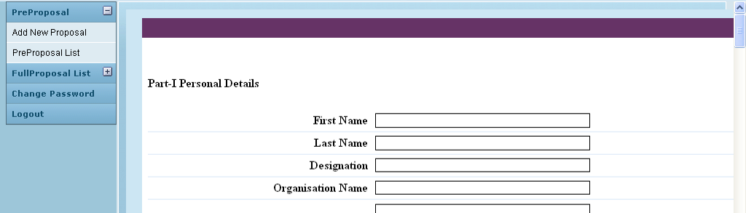
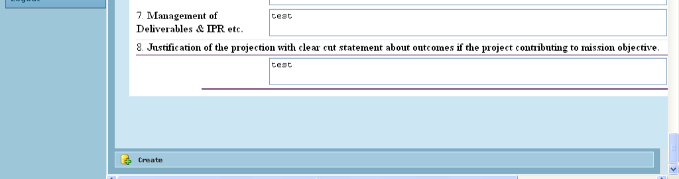

Field /Label | Input-Control | Data Type | Details
Create | Button |  | The details filled in the form are saved

After filling in the details, on clicking Create, the user is given options to – save the document as draft or to submit to authorities for review.
Figure 8: Staff - Save/submit pre-proposal
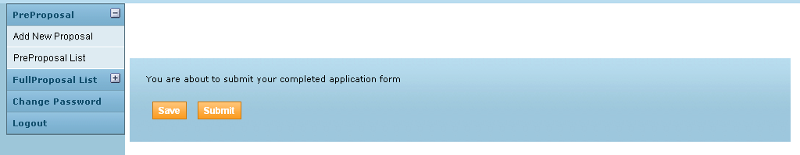
Field /Label | Input-Control | Data Type | Details
You are about to submit your completed application form.
Save | Button |  | The details filled in the form are saved
Submit | Button |  | The details are saved and the form is submitted to the GMS.

The screen below shows the Staff‘s list of pre-proposals which have been submitted so far and their status. ‘Reviewing” status (set automatically on submitting) indicates that the pre-proposal submitted is under review. If the user had chosen to save as draft then this field would have displayed “Saved”.
Figure 9: Staff - Pre proposal List
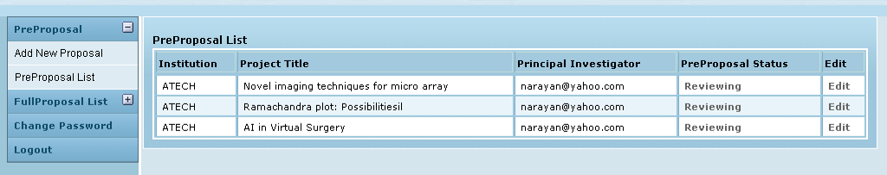

Field /Label | Input-Control | Details
Pre proposal List
Institution | Auto populated | party>code
Project Title | Auto populated | pre_proposal>project_title
Principal Investigator | Auto populated | investigator>name
Pre proposal Status | Auto populated Link | Shows the page as in Fig 11.
Edit | Link

Edit button allows editing and re-submitting of the pre-proposals.
When in “Reviewing” status, clicking on “Reviewing” will open the following page:
Figure 10: Staff - Pre proposal review status
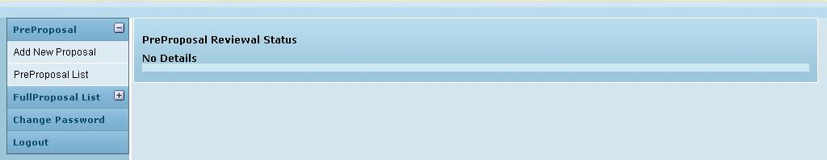

Field /Label | Input-Control | Data Type | Details
Pre proposal review status
<No Details>

Currently there are no details shown. Once the admin assigns the pre-proposal to the approval authorities, sets the start order, restart order etc, those details are shown here. (Fig 19). Also the levels of approval that are over are also displayed with the review results.
After reviewing the Pre-proposal status field displays “Approved” or “Rejected”, as the case may be or “Need more info” in which case the staff should re-submit.
This process is described below:

Proposal Authority Mapping

The admin logs in the system and on the left menu panel, clicks Proposal Authority map. When the menu expands, the admin clicks on Assign proposal to approval authority sub menu. The screen is shown below:

Figure 11: Admin - Assign proposal to Approval Authority
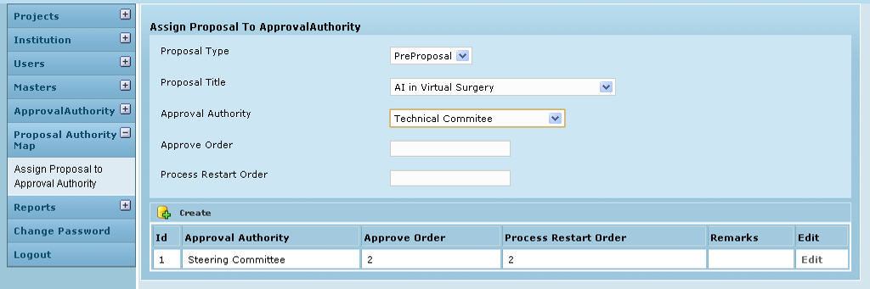

Field /Label | Input-Control |  | Data Type | Details
Assign Proposal to Approval Authority
Proposal Type |  | List box | Varchar(255) | proposal_approval_authority_map>  proposal_type
Proposal Title |  | List box | Varchar(255) | pre_proposal>project_title
Approval Authority |  | List box | Varchar(255) | approval_authority>name
Approve order |  | Textbox | Int(11) | proposal_approval_authority_map>  approve_order
Process Restart Order |  | Textbox | Int(11) | proposal_approval_authority_map>  process_restart_order
Create |  | Button
ID |  | Auto increment
Approval Authority |  | Auto populated
Approve Order |  | Auto populated
Process Restart order |  | Auto populated
Remarks |  | Auto populated
Edit |  | Link |  | Opens the edit page to modify the details captured here.

The details can also be edited at a later time.
Figure 12: Admin – Edit proposal-approval authority map
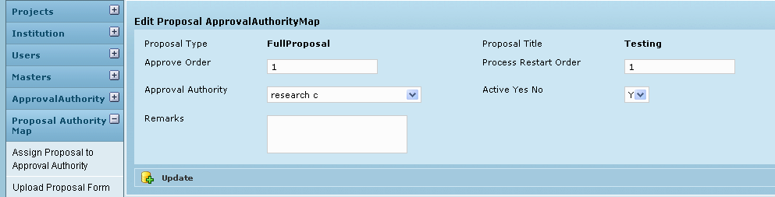

Field /Label | Input-Control | Data Type | DB Table>field
Proposal Type | < > |  | proposal_approval_authority_map>  proposal_type
Proposal Title | < > |  | pre_proposal>project_title
Approval Authority | Auto populated but editable List box | Varchar(255) | approval_authority>name
Active Yes No | Auto populated but editable List box | Char(1) | proposal_approval_authority_map>active_yes_no
Approve order | Auto populated but editable Textbox | Int(11) | proposal_approval_authority_map>  approve_order
Process Restart Order | Auto populated but editable Textbox | Int(11) | proposal_approval_authority_map>  process_restart_order
Update | Button
Delete | Button

Once the admin saves the above details, the pre-proposal details get populated for each member of the approval authorities to whom the specific pre-proposal was assigned. A sample screen of a reviewer is shown below in Fig 17:

Pre – proposal Review

The reviewer log in, clicks Pre proposal menu on the left and when the menu expands, clicks Pre proposal Approval. The list of proposals to be reviewed by this reviewer at various evaluation levels is displayed here.
Figure 13: Reviewer – Pre proposal List
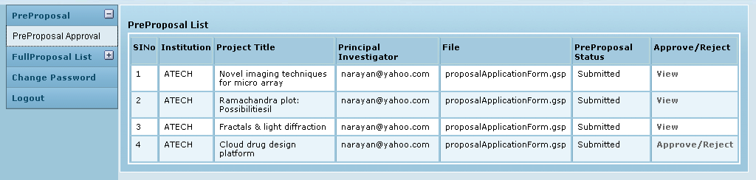
Field /Label | Input-Control | Data Type | Details
Pre proposal List
Sl No | Auto incremented
Institution | Auto populated |  | party>code
Project Title | Auto populated |  | pre_proposal>project_title
Principal Investigator | Auto populated |  | investigator>name
File | Auto populated |  | pre_proposal>pre_proposal_form
Pre proposal Status | Auto populated |  | pre_proposal>pre_proposal_status
<Approve/Reject> or <View> | Auto populated (Link) | “View” is displayed in “Approve/Reject” column when the particular reviewer’s level of review has not started yet. So the privilege is only to view the proposal. Once the review at levels below are over, then “Approve/Reject” status link appears

If, for a particular pre-proposal, this reviewer belongs to the approval authority of the first level (Approve order – 1), then in the Approve /Reject column the corresponding status will be “Approve/Reject”. On clicking this status label, the pre-proposal is opened and the reviewer is provided with 3 buttons – Accept, Need more info, Reject.
But if the reviewer belongs to any other authority level, then till the pre-proposal passes through the other levels before his own, the status in the Approve /Reject column will be “View” for this reviewer (and all others at this authority level). On clicking View, the pre-proposal form can be opened and viewed only.

Figure 14: Reviewer – Pre proposal details
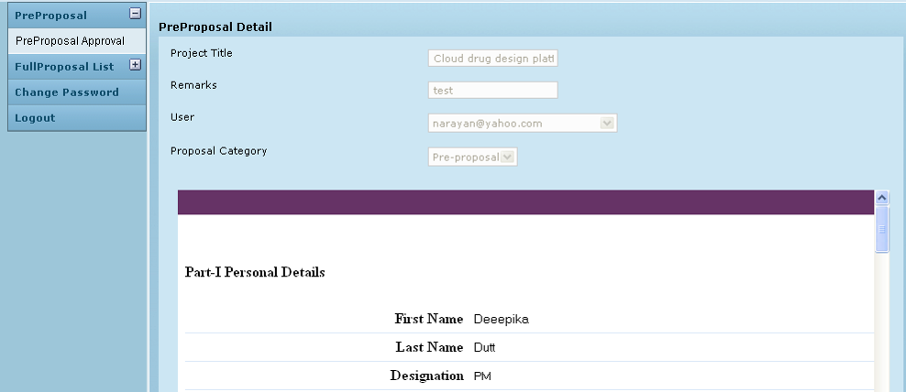
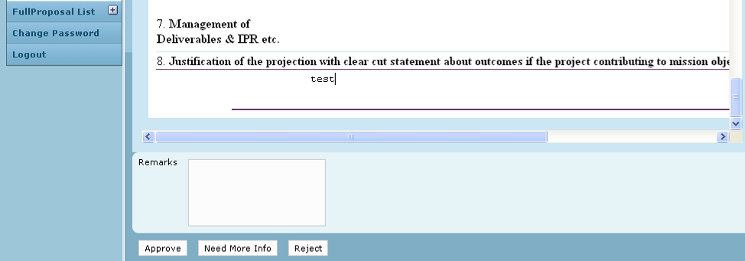

Field /Label | Input-Control | Data Type | Details
Project Title | Auto populated disabled Textbox | Details saved through Add new proposal while creating this pre-proposal.
Remarks | Auto populated disabled Textbox
User | Auto populated disabled Listbox
Proposal Category | Auto populated disabled Listbox
Remarks | Text area | Varchar(255) | The entry here is displayed in the status remarks column in the staff login
 |  | Once set, the status is displayed in the status column for the proposal in staff login
Approve | Button | Pre-proposal is approved and the line item appears in the Full proposal list for the particular staff. Now he may submit the full proposal for review.
Need more info | Button | Once set, the particular staff is expected to resubmit after making changes
Reject | Button | the pre-proposal is rejected

The reviewer has been provided with a text area to input comments.
Once a suitable status (Approved) is selected, the line item disappears from the specific reviewer’s list and the line item populates the reviewers’ lists at the next authority level.
If “Need more info” status is selected, then the line item returns to the Staff’s list. The Staff can resubmit after adding the required details and the chain now follows the Process Restart order.
Figure 15: Reviewer - Pre proposal status
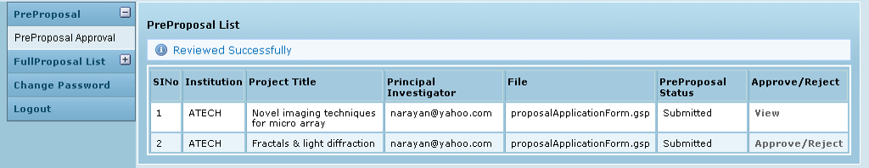

As can be seen below, the last line item in the table has an “Approved” status
The reviewer can view the proposals he has reviewed in the past on a different page:

Figure 16: Reviewer - Pre proposal - view past reviews
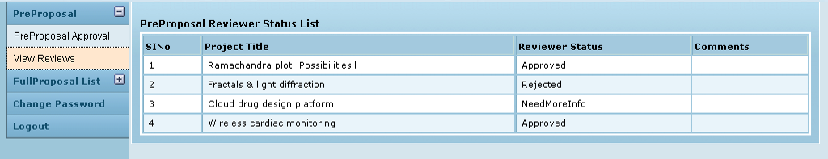

Field /Label | Input-Control
Sl No | Auto increment
Project Title | Auto populated
Reviewer Status | Auto populated
Comments | Auto populated

Meanwhile, the staff person can track the review status in his log in, in the Pre Proposal List.

Figure 17: Staff - Pre proposal status tracking
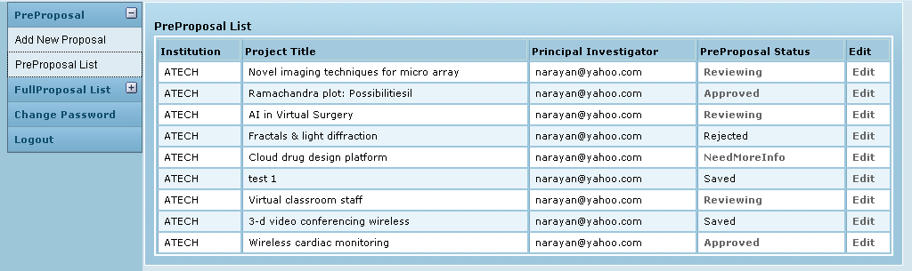
Field /Label | Input-Control | Data Type | Details
Pre proposal List
Institution | Auto populated |  | party>code
Project Title | Auto populated |  | pre_proposal>project_title
Principal Investigator | Auto populated |  | investigator>name
Pre proposal Status | Auto populated |  | pre_proposal>pre_proposal_status
Edit | Link |  | Allows editing of the submitted pre proposal document.

Post review, clicking in the status for any line item, displays details as shown below:
Figure 18: Staff - Pre proposal review status
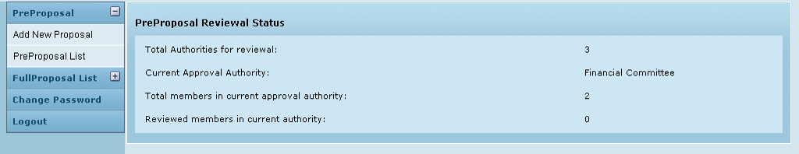
Field /Label | Input-Control | Data Type | Details
Pre proposal review status
Total Authorities for review | < > | Integer | total number of approval authorities to which the proposal has been assigned
Current approval authority | < > | Varchar(255) | the authority currently reviewing
Total members in current approval authority | < > | Integer | Total number of members in current approving authority
Reviewed members in current authority | < > | Integer | total number of members in the current approving authority who have already reviewed

Submission of Full proposals by staff members

The approved pre-proposals details also get automatically populated in the Full Proposal List for the Staff. In figure 18, 2 pre-proposals were approved. The same 2 are now displayed in Fig 22 below.
Figure 19: Staff – Full proposal List
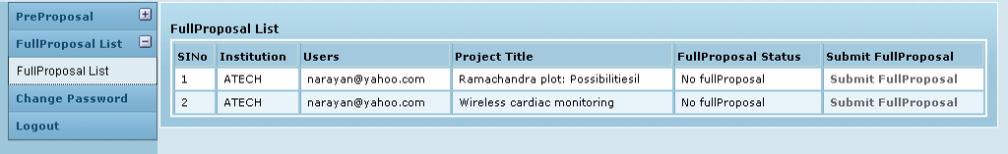

Field /Label | Input-Control
Pre proposal List
Institution | Auto populated | party>code
Project Title | Auto populated | pre_proposal>project_title
Users | Auto populated | investigator>name
Full proposal status | Auto populated | full_proposal>proposal_status
Submit Full Proposal | Link

By clicking Submit Full proposal for a line item here, the staff will open the proposal uploading page as shown below in Figure 21. The Full Proposal Status displays No Full Proposal for both the line items indicating that proposals have not been uploaded yet. By clicking Submit Full Proposal for each line item, screen as shown in Fig 21 below can be opened. Here the proposal can be uploaded and saved or submitted (just as in the case of pre-proposal)
Figure 20: Staff – Full proposal upload
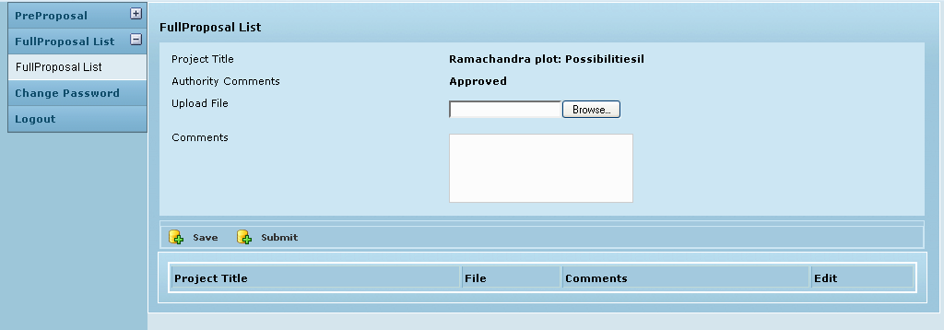

Field /Label | Input-Control | Data Type | Details
Full Proposal List
Project Title | < > | Varchar(255) | pre_proposal>project_title
Authority Comments | < > | Varchar(255) | pre_proposal>proposal_status
Upload File | Textbox Browse button | Varchar(255)
Comments | Text area | Varchar(255) | full_proposal_detail>comments
Save | Button
Submit | Button
Project Title | Auto populated |  | pre_proposal>project_title
File | Auto populated |  | full_proposal_detail>file_name
Comments | Auto populated |  | full_proposal_detail>comments
Edit | Link

Once the proposals are submitted, the status in Full Proposal List – Full Proposal Status column changes to Reviewing.
Figure 21: Staff – Full Proposal List – Status
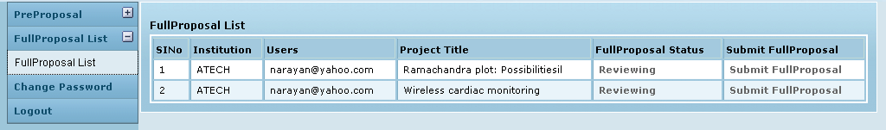

Field /Label | Input-Control | Details
Full proposal list
SlNo
Institution | Auto populated | party>code
Users | Auto populated
Project Title | Auto populated | pre_proposal>project_title
Full proposal Status | Auto populated Link | “View” is displayed in “Approve/Reject” column when the particular reviewer’s level of review has not started yet. So the privilege is only to view the proposal. Once the review at levels below are over, then “Approve/Reject” status link appears
Submit full proposal | Link

Here onwards the process is same as that for pre-proposal. The admin maps the approval authorities for the submitted full proposals and so the details get populated as lie items for the various reviewers.
As the review happens the staff member can view the status of his full proposal. A sample screen is given below:
Figure 22: Staff - Full proposal Review Status details
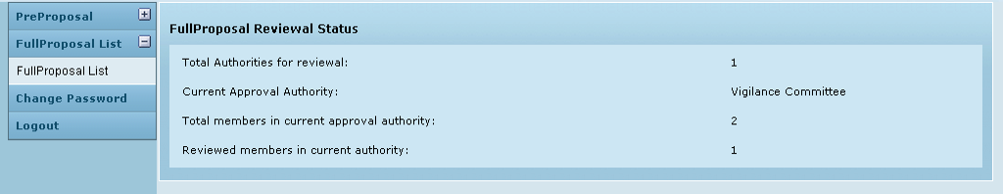

Field /Label | Input-Control | Details
Full proposal review status
Total Authorities for review | < > | total number of approval authorities to which the proposal has been assigned
Current approval authority | < > | the authority currently reviewing
Total members in current approval authority | < > | Total number of members in current approving authority
Reviewed members in current authority | < > | total number of members in the current approving authority who have already reviewed

The routing for approval happens as per the given process and restart orders. Finally the approved /rejected status is displayed in the Full Proposal List for the staff to see.

The reviewer can view the past review results at:

Figure 23: Reviewer - Full Proposal - View past reviews
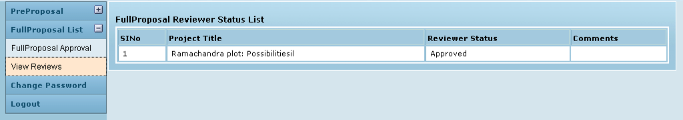

Field /Label | Input-Control | Details
Full Proposal Review Status List
Sl No | Auto increment
Project Title | Auto populated | pre_proposal>project_title
Reviewer Status | Auto populated | proposal_approval_detail>proposal_status
Comments | Auto populated | proposal_approval_detail>more_comments

Associated Tables

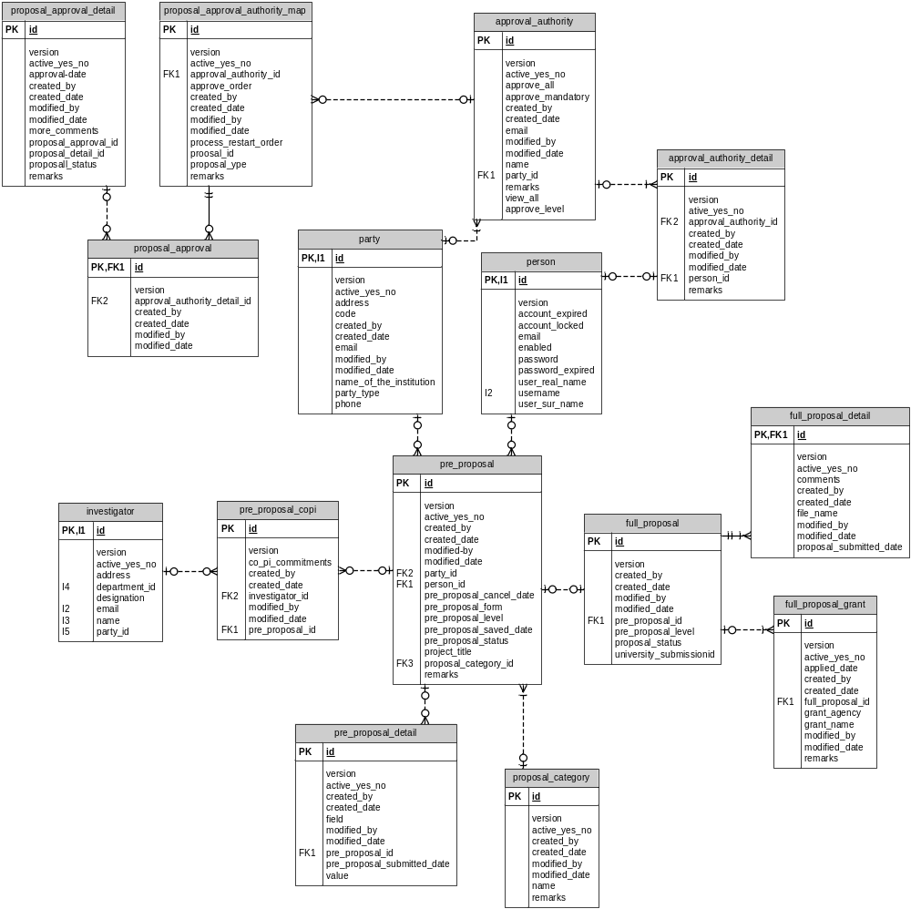

Active_yes_no field has been added in the gms_setting table.

Data Dictionary

approval_authority

Fields

Field | Type | Collation | Null | Key | Default | Extra | Privileges
id | bigint(20) | (NULL) | NO | PRI | (NULL) | auto_increment | select,insert,update,references
version | bigint(20) | (NULL) | NO |  |  |  | select,insert,update,references
active_yes_no | char(1) | latin1_swedish_ci | NO |  |  |  | select,insert,update,references
approve_all | char(1) | latin1_swedish_ci | NO |  |  |  | select,insert,update,references
approve_mandatory | char(1) | latin1_swedish_ci | NO |  |  |  | select,insert,update,references
created_by | varchar(255) | latin1_swedish_ci | YES |  | (NULL) |  | select,insert,update,references
created_date | datetime | (NULL) | YES |  | (NULL) |  | select,insert,update,references
email | varchar(255) | latin1_swedish_ci | YES |  | (NULL) |  | select,insert,update,references
modified_by | varchar(255) | latin1_swedish_ci | YES |  | (NULL) |  | select,insert,update,references
modified_date | datetime | (NULL) | YES |  | (NULL) |  | select,insert,update,references
name | varchar(255) | latin1_swedish_ci | NO |  |  |  | select,insert,update,references
party_id | bigint(20) | (NULL) | NO | MUL |  |  | select,insert,update,references
remarks | varchar(255) | latin1_swedish_ci | YES |  | (NULL) |  | select,insert,update,references
view_all | char(1) | latin1_swedish_ci | NO |  |  |  | select,insert,update,references
approve_level | varchar(255) | latin1_swedish_ci | YES |  | (NULL) |  | select,insert,update,references
default_yes_no | char(1) | latin1_swedish_ci | YES |  | (NULL) |  | select,insert,update,references

Indexes

Table | Non  unique | Key  name | Seq  in  index | Column  name | Collation | Cardinality | Sub  part | Packed | Null | Index  type
approval_authority | 0 | PRIMARY | 1 | id | A | 171 | (NULL) | (NULL) |  | BTREE
approval_authority | 1 | FK12ADB0474B78CFDA | 1 | party_id | A | 28 | (NULL) | (NULL) |  | BTREE

Foreign Key Relationships

FK Id | Reference Table | Source Column | Target Column | Extra Info
FK12ADB0474B78CFDA | party | `party_id` | `id`
approval_authority_detail

Fields

Field | Type | Collation | Null | Key | Default | Extra | Privileges
id | bigint(20) | (NULL) | NO | PRI | (NULL) | auto_increment | select,insert,update,references
version | bigint(20) | (NULL) | NO |  |  |  | select,insert,update,references
active_yes_no | char(1) | latin1_swedish_ci | NO |  |  |  | select,insert,update,references
approval_authority_id | bigint(20) | (NULL) | NO | MUL |  |  | select,insert,update,references
created_by | varchar(255) | latin1_swedish_ci | YES |  | (NULL) |  | select,insert,update,references
created_date | datetime | (NULL) | YES |  | (NULL) |  | select,insert,update,references
modified_by | varchar(255) | latin1_swedish_ci | YES |  | (NULL) |  | select,insert,update,references
modified_date | datetime | (NULL) | YES |  | (NULL) |  | select,insert,update,references
person_id | bigint(20) | (NULL) | NO | MUL |  |  | select,insert,update,references
remarks | varchar(255) | latin1_swedish_ci | YES |  | (NULL) |  | select,insert,update,references

Indexes

Table | Non  unique | Key  name | Seq  in  index | Column  name | Collation | Cardinality | Sub  part | Packed | Null | Index  type
approval_authority_detail | 0 | PRIMARY | 1 | id | A | 1755 | (NULL) | (NULL) |  | BTREE
approval_authority_detail | 1 | FKF0D9D749F1C66433 | 1 | approval_  authority_id | A | 195 | (NULL) | (NULL) |  | BTREE
approval_authority_detail | 1 | FKF0D9D749C12321BA | 1 | person_id | A | 159 | (NULL) | (NULL) |  | BTREE

Foreign Key Relationships

FK Id | Reference Table | Source Column | Target Column | Extra Info
FKF0D9D749C12321BA | person | `person_id` | `id` | ,
FKF0D9D749F1C66433 | approval_authority | `approval_authority_id` | `id`
full_proposal

Fields

Field | Type | Collation | Null | Key | Default | Extra | Privileges
id | bigint(20) | (NULL) | NO | PRI | (NULL) | auto_increment | select,insert,update,references
version | bigint(20) | (NULL) | NO |  |  |  | select,insert,update,references
created_by | varchar(255) | latin1_swedish_ci | YES |  | (NULL) |  | select,insert,update,references
created_date | datetime | (NULL) | YES |  | (NULL) |  | select,insert,update,references
modified_by | varchar(255) | latin1_swedish_ci | YES |  | (NULL) |  | select,insert,update,references
modified_date | datetime | (NULL) | YES |  | (NULL) |  | select,insert,update,references
pre_proposal_id | bigint(20) | (NULL) | NO | MUL |  |  | select,insert,update,references
pre_proposal_level | int(11) | (NULL) | NO |  |  |  | select,insert,update,references
proposal_status | varchar(255) | latin1_swedish_ci | YES |  | (NULL) |  | select,insert,update,references
university_submissionid | varchar(255) | latin1_swedish_ci | YES |  | (NULL) |  | select,insert,update,references

Indexes

Table | Non  unique | Key  name | Seq  in  index | Column  name | Collation | Cardinality | Sub  part | Packed | Null | Index  type
full_proposal | 0 | PRIMARY | 1 | id | A | 72 | (NULL) | (NULL) |  | BTREE
full_proposal | 1 | FK3613EAA2D3C5D481 | 1 | pre_proposal_id | A | 72 | (NULL) | (NULL) |  | BTREE

Foreign Key Relationships

FK Id | Reference Table | Source Column | Target Column | Extra Info
FK3613EAA2D3C5D481 | pre_proposal | `pre_proposal_id` | `id`
full_proposal_detail

Fields

Field | Type | Collation | Null | Key | Default | Extra | Privileges
id | bigint(20) | (NULL) | NO | PRI | (NULL) | auto_increment | select,insert,update,references
version | bigint(20) | (NULL) | NO |  |  |  | select,insert,update,references
active_yes_no | char(1) | latin1_swedish_ci | NO |  |  |  | select,insert,update,references
comments | varchar(255) | latin1_swedish_ci | YES |  | (NULL) |  | select,insert,update,references
created_by | varchar(255) | latin1_swedish_ci | YES |  | (NULL) |  | select,insert,update,references
created_date | datetime | (NULL) | YES |  | (NULL) |  | select,insert,update,references
file_name | varchar(255) | latin1_swedish_ci | NO |  |  |  | select,insert,update,references
full_proposal_id | bigint(20) | (NULL) | NO | MUL |  |  | select,insert,update,references
modified_by | varchar(255) | latin1_swedish_ci | YES |  | (NULL) |  | select,insert,update,references
modified_date | datetime | (NULL) | YES |  | (NULL) |  | select,insert,update,references
proposal_submitted_date | datetime | (NULL) | NO |  |  |  | select,insert,update,references

Indexes

Table | Non  unique | Key  name | Seq  in  index | Column  name | Collation | Cardinality | Sub  part | Packed | Null | Index  type
full_proposal_detail | 0 | PRIMARY | 1 | id | A | 70 | (NULL) | (NULL) |  | BTREE
full_proposal_detail | 1 | FK3FE9508EA3573299 | 1 | full_proposal_id | A | 70 | (NULL) | (NULL) |  | BTREE

Foreign Key Relationships

FK Id | Reference Table | Source Column | Target Column | Extra Info
FK3FE9508EA3573299 | full_proposal | `full_proposal_id` | `id`
full_proposal_grant

Fields

Field | Type | Collation | Null | Key | Default | Extra | Privileges
id | bigint(20) | (NULL) | NO | PRI | (NULL) | auto_increment | select,insert,update,references
version | bigint(20) | (NULL) | NO |  |  |  | select,insert,update,references
active_yes_no | char(1) | latin1_swedish_ci | NO |  |  |  | select,insert,update,references
applied_date | datetime | (NULL) | NO |  |  |  | select,insert,update,references
created_by | varchar(255) | latin1_swedish_ci | YES |  | (NULL) |  | select,insert,update,references
created_date | datetime | (NULL) | YES |  | (NULL) |  | select,insert,update,references
full_proposal_id | bigint(20) | (NULL) | NO | MUL |  |  | select,insert,update,references
grant_agency | varchar(255) | latin1_swedish_ci | NO |  |  |  | select,insert,update,references
grant_name | varchar(255) | latin1_swedish_ci | NO |  |  |  | select,insert,update,references
modified_by | varchar(255) | latin1_swedish_ci | YES |  | (NULL) |  | select,insert,update,references
modified_date | datetime | (NULL) | YES |  | (NULL) |  | select,insert,update,references
remarks | varchar(255) | latin1_swedish_ci | YES |  | (NULL) |  | select,insert,update,references

Indexes

Table | Non  unique | Key  name | Seq  in  index | Column  name | Collation | Cardinality | Sub  part | Packed | Null | Index  type
full_proposal_grant | 0 | PRIMARY | 1 | id | A | 0 | (NULL) | (NULL) |  | BTREE
full_proposal_grant | 1 | FKAFAB0D3FA3573299 | 1 | full_proposal_id | A | 0 | (NULL) | (NULL) |  | BTREE

Foreign Key Relationships

FK Id | Reference Table | Source Column | Target Column | Extra Info
FKAFAB0D3FA3573299 | full_proposal | `full_proposal_id` | `id`
party

Fields

Field | Type | Collation | Null | Key | Default | Extra | Privileges
id | bigint(20) | (NULL) | NO | PRI | (NULL) | auto_increment | select,insert,update,references
version | bigint(20) | (NULL) | NO |  |  |  | select,insert,update,references
active_yes_no | char(1) | latin1_swedish_ci | NO |  |  |  | select,insert,update,references
address | varchar(255) | latin1_swedish_ci | NO |  |  |  | select,insert,update,references
code | varchar(255) | latin1_swedish_ci | NO |  |  |  | select,insert,update,references
created_by | varchar(255) | latin1_swedish_ci | NO |  |  |  | select,insert,update,references
created_date | datetime | (NULL) | YES |  | (NULL) |  | select,insert,update,references
email | varchar(255) | latin1_swedish_ci | NO |  |  |  | select,insert,update,references
modified_by | varchar(255) | latin1_swedish_ci | YES |  | (NULL) |  | select,insert,update,references
modified_date | datetime | (NULL) | YES |  | (NULL) |  | select,insert,update,references
name_of_the_institution | varchar(255) | latin1_swedish_ci | NO |  |  |  | select,insert,update,references
party_type | varchar(255) | latin1_swedish_ci | YES |  | (NULL) |  | select,insert,update,references
phone | varchar(255) | latin1_swedish_ci | NO |  |  |  | select,insert,update,references

Indexes

Table | Non  unique | Key  name | Seq  in  index | Column  name | Collation | Cardinality | Sub  part | Packed | Null | Index  type
party | 0 | PRIMARY | 1 | id | A | 66 | (NULL) | (NULL) |  | BTREE
person

Fields

Field | Type | Collation | Null | Key | Default | Extra | Privileges
id | bigint(20) | (NULL) | NO | PRI | (NULL) | auto_increment | select,insert,update,references
version | bigint(20) | (NULL) | NO |  |  |  | select,insert,update,references
account_expired | bit(1) | (NULL) | NO |  |  |  | select,insert,update,references
account_locked | bit(1) | (NULL) | NO |  |  |  | select,insert,update,references
email | varchar(255) | latin1_swedish_ci | NO |  |  |  | select,insert,update,references
enabled | bit(1) | (NULL) | NO |  |  |  | select,insert,update,references
password | varchar(255) | latin1_swedish_ci | NO |  |  |  | select,insert,update,references
password_expired | bit(1) | (NULL) | NO |  |  |  | select,insert,update,references
user_real_name | varchar(255) | latin1_swedish_ci | NO |  |  |  | select,insert,update,references
user_sur_name | varchar(255) | latin1_swedish_ci | YES |  | (NULL) |  | select,insert,update,references
username | varchar(255) | latin1_swedish_ci | NO | UNI |  |  | select,insert,update,references

Indexes

Table | Non  unique | Key  name | Seq  in  index | Column  name | Collation | Cardinality | Sub  part | Packed | Null | Index  type
person | 0 | PRIMARY | 1 | id | A | 328 | (NULL) | (NULL) |  | BTREE
person | 0 | username | 1 | username | A | 328 | (NULL) | (NULL) |  | BTREE
pre_proposal

Fields

Field | Type | Collation | Null | Key | Default | Extra | Privileges
id | bigint(20) | (NULL) | NO | PRI | (NULL) | auto_increment | select,insert,update,references
version | bigint(20) | (NULL) | NO |  |  |  | select,insert,update,references
active_yes_no | char(1) | latin1_swedish_ci | NO |  |  |  | select,insert,update,references
created_by | varchar(255) | latin1_swedish_ci | YES |  | (NULL) |  | select,insert,update,references
created_date | datetime | (NULL) | YES |  | (NULL) |  | select,insert,update,references
modified_by | varchar(255) | latin1_swedish_ci | YES |  | (NULL) |  | select,insert,update,references
modified_date | datetime | (NULL) | YES |  | (NULL) |  | select,insert,update,references
party_id | bigint(20) | (NULL) | NO | MUL |  |  | select,insert,update,references
person_id | bigint(20) | (NULL) | NO | MUL |  |  | select,insert,update,references
pre_proposal_cancel_date | datetime | (NULL) | YES |  | (NULL) |  | select,insert,update,references
pre_proposal_form | varchar(255) | latin1_swedish_ci | NO |  |  |  | select,insert,update,references
pre_proposal_level | int(11) | (NULL) | NO |  |  |  | select,insert,update,references
pre_proposal_saved_date | datetime | (NULL) | YES |  | (NULL) |  | select,insert,update,references
pre_proposal_status | varchar(255) | latin1_swedish_ci | YES |  | (NULL) |  | select,insert,update,references
project_title | varchar(255) | latin1_swedish_ci | YES |  | (NULL) |  | select,insert,update,references
proposal_category_id | bigint(20) | (NULL) | NO | MUL |  |  | select,insert,update,references
remarks | varchar(255) | latin1_swedish_ci | YES |  | (NULL) |  | select,insert,update,references

Indexes

Table | Non  unique | Key  name | Seq  in  index | Column  name | Collation | Cardinality | Sub  part | Packed | Null | Index  type
pre_proposal | 0 | PRIMARY | 1 | id | A | 320 | (NULL) | (NULL) |  | BTREE
pre_proposal | 1 | FKD6C1310E2F0F585F | 1 | proposal_category_id | A | 40 | (NULL) | (NULL) |  | BTREE
pre_proposal | 1 | FKD6C1310E4B78CFDA | 1 | party_id | A | 32 | (NULL) | (NULL) |  | BTREE
pre_proposal | 1 | FKD6C1310EC12321BA | 1 | person_id | A | 45 | (NULL) | (NULL) |  | BTREE

Foreign Key Relationships

FK Id | Reference Table | Source Column | Target Column | Extra Info
FKD6C1310EC12321BA | person | `person_id` | `id` | ,
FKD6C1310E2F0F585F | proposal_category | `proposal_category_id` | `id` | ,
FKD6C1310E4B78CFDA | party | `party_id` | `id`
pre_proposal_copi

Fields

Field | Type | Collation | Null | Key | Default | Extra | Privileges
id | bigint(20) | (NULL) | NO | PRI | (NULL) | auto_increment | select,insert,update,references
version | bigint(20) | (NULL) | NO |  |  |  | select,insert,update,references
co_pi_commitments | varchar(255) | latin1_swedish_ci | YES |  | (NULL) |  | select,insert,update,references
created_by | varchar(255) | latin1_swedish_ci | YES |  | (NULL) |  | select,insert,update,references
created_date | datetime | (NULL) | YES |  | (NULL) |  | select,insert,update,references
investigator_id | bigint(20) | (NULL) | NO | MUL |  |  | select,insert,update,references
modified_by | varchar(255) | latin1_swedish_ci | YES |  | (NULL) |  | select,insert,update,references
modified_date | datetime | (NULL) | YES |  | (NULL) |  | select,insert,update,references
pre_proposal_id | bigint(20) | (NULL) | NO | MUL |  |  | select,insert,update,references

Indexes

Table | Non  unique | Key  name | Seq  in  index | Column  name | Collation | Cardinality | Sub  part | Packed | Null | Index  type
pre_proposal_copi | 0 | PRIMARY | 1 | id | A | 0 | (NULL) | (NULL) |  | BTREE
pre_proposal_copi | 1 | FKF4A2AFF6D3C5D481 | 1 | pre_proposal_id | A | 0 | (NULL) | (NULL) |  | BTREE
pre_proposal_copi | 1 | FKF4A2AFF6893BB93A | 1 | investigator_id | A | 0 | (NULL) | (NULL) |  | BTREE

Foreign Key Relationships

FK Id | Reference Table | Source Column | Target Column | Extra Info
FKF4A2AFF6893BB93A | investigator | `investigator_id` | `id` | ,
FKF4A2AFF6D3C5D481 | pre_proposal | `pre_proposal_id` | `id`
pre_proposal_detail

Fields

Field | Type | Collation | Null | Key | Default | Extra | Privileges
id | bigint(20) | (NULL) | NO | PRI | (NULL) | auto_increment | select,insert,update,references
version | bigint(20) | (NULL) | NO |  |  |  | select,insert,update,references
active_yes_no | char(1) | latin1_swedish_ci | NO |  |  |  | select,insert,update,references
created_by | varchar(255) | latin1_swedish_ci | YES |  | (NULL) |  | select,insert,update,references
created_date | datetime | (NULL) | YES |  | (NULL) |  | select,insert,update,references
field | varchar(255) | latin1_swedish_ci | YES |  | (NULL) |  | select,insert,update,references
modified_by | varchar(255) | latin1_swedish_ci | YES |  | (NULL) |  | select,insert,update,references
modified_date | datetime | (NULL) | YES |  | (NULL) |  | select,insert,update,references
pre_proposal_id | bigint(20) | (NULL) | NO | MUL |  |  | select,insert,update,references
pre_proposal_  submitted_date | datetime | (NULL) | YES |  | (NULL) |  | select,insert,update,references
value | varchar(255) | latin1_swedish_ci | YES |  | (NULL) |  | select,insert,update,references

Indexes

Table | Non  unique | Key  name | Seq  in  index | Column  name | Collation | Cardinality | Sub  part | Packed | Null | Index  type
pre_proposal_detail | 0 | PRIMARY | 1 | id | A | 8161 | (NULL) | (NULL) |  | BTREE
pre_proposal_detail | 1 | FK57E038A2D3C5D481 | 1 | pre_proposal_id | A | 453 | (NULL) | (NULL) |  | BTREE

Foreign Key Relationships

FK Id | Reference Table | Source Column | Target Column | Extra Info
FK57E038A2D3C5D481 | pre_proposal | `pre_proposal_id` | `id`
proposal_approval

Fields

Field | Type | Collation | Null | Key | Default | Extra | Privileges
id | bigint(20) | (NULL) | NO | PRI | (NULL) | auto_increment | select,insert,update,references
version | bigint(20) | (NULL) | NO |  |  |  | select,insert,update,references
approval_authority  _detail_id | bigint(20) | (NULL) | NO | MUL |  |  | select,insert,update,references
created_by | varchar(255) | latin1_swedish_ci | YES |  | (NULL) |  | select,insert,update,references
created_date | datetime | (NULL) | YES |  | (NULL) |  | select,insert,update,references
modified_by | varchar(255) | latin1_swedish_ci | YES |  | (NULL) |  | select,insert,update,references
modified_date | datetime | (NULL) | YES |  | (NULL) |  | select,insert,update,references
proposal_approval_  authority_map_id | bigint(20) | (NULL) | NO | MUL |  |  | select,insert,update,references

Indexes

Table | Non  unique | Key  name | Seq  in  index | Column  name | Collation | Cardinality | Sub  part | Packed | Null | Index  type
proposal_approval | 0 | PRIMARY | 1 | id | A | 1015 | (NULL) | (NULL) |  | BTREE
proposal_approval | 1 | FK29BC5CF0E5B73262 | 1 | approval_authority  _detail_id | A | 1015 | (NULL) | (NULL) |  | BTREE
proposal_approval | 1 | FK29BC5CF0A1E745F7 | 1 | proposal_approval  _authority_map_id | A | 338 | (NULL) | (NULL) |  | BTREE

Foreign Key Relationships

FK Id | Reference Table | Source Column | Target Column | Extra Info
FK29BC5CF0A1E745F7 | proposal_approval_authority_map | `proposal_approval_authority_map_id` | `id` | ,
FK29BC5CF0E5B73262 | approval_authority_detail | `approval_authority_detail_id` | `id`
proposal_approval_authority_map

Fields

Field | Type | Collation | Null | Key | Default | Extra | Privileges
id | bigint(20) | (NULL) | NO | PRI | (NULL) | auto_increment | select,insert,update,references
version | bigint(20) | (NULL) | NO |  |  |  | select,insert,update,references
active_yes_no | char(1) | latin1_swedish_ci | NO |  |  |  | select,insert,update,references
approval_authority_id | bigint(20) | (NULL) | NO | MUL |  |  | select,insert,update,references
approve_order | int(11) | (NULL) | NO |  |  |  | select,insert,update,references
created_by | varchar(255) | latin1_swedish_ci | YES |  | (NULL) |  | select,insert,update,references
created_date | datetime | (NULL) | YES |  | (NULL) |  | select,insert,update,references
modified_by | varchar(255) | latin1_swedish_ci | YES |  | (NULL) |  | select,insert,update,references
modified_date | datetime | (NULL) | YES |  | (NULL) |  | select,insert,update,references
process_restart_order | int(11) | (NULL) | NO |  |  |  | select,insert,update,references
proposal_id | int(11) | (NULL) | NO |  |  |  | select,insert,update,references
proposal_type | varchar(255) | latin1_swedish_ci | NO |  |  |  | select,insert,update,references
remarks | varchar(255) | latin1_swedish_ci | YES |  | (NULL) |  | select,insert,update,references

Indexes

Table | Non  unique | Key  name | Seq  in  index | Column  name | Collation | Cardinality | Sub  part | Packed | Null | Index  type
proposal_approval  _authority_map | 0 | PRIMARY | 1 | id | A | 335 | (NULL) | (NULL) |  | BTREE
proposal_approva  l_authority_map | 1 | FKFE624D51F1C66433 | 1 | approval_authority_id | A | 167 | (NULL) | (NULL) |  | BTREE

Foreign Key Relationships

FK Id | Reference Table | Source Column | Target Column | Extra Info
FKFE624D51F1C66433 | approval_authority | `approval_authority_id` | `id`
proposal_approval_detail

Fields

Field | Type | Collation | Null | Key | Default | Extra | Privileges
id | bigint(20) | (NULL) | NO | PRI | (NULL) | auto_increment | select,insert,update,references
version | bigint(20) | (NULL) | NO |  |  |  | select,insert,update,references
active_yes_no | char(1) | latin1_swedish_ci | NO |  |  |  | select,insert,update,references
approval_date | datetime | (NULL) | NO |  |  |  | select,insert,update,references
created_by | varchar(255) | latin1_swedish_ci | YES |  | (NULL) |  | select,insert,update,references
created_date | datetime | (NULL) | YES |  | (NULL) |  | select,insert,update,references
modified_by | varchar(255) | latin1_swedish_ci | YES |  | (NULL) |  | select,insert,update,references
modified_date | datetime | (NULL) | YES |  | (NULL) |  | select,insert,update,references
more_comments | varchar(255) | latin1_swedish_ci | YES |  | (NULL) |  | select,insert,update,references
proposal_approval_id | bigint(20) | (NULL) | NO | MUL |  |  | select,insert,update,references
proposal_detail_id | double | (NULL) | NO |  |  |  | select,insert,update,references
proposal_status | varchar(255) | latin1_swedish_ci | NO |  |  |  | select,insert,update,references
remarks | varchar(255) | latin1_swedish_ci | YES |  | (NULL) |  | select,insert,update,references

Indexes

Table | Non  unique | Key  name | Seq  in  index | Column  name | Collation | Cardinality | Sub  part | Packed | Null | Index  type
proposal_approval  _detail | 0 | PRIMARY | 1 | id | A | 377 | (NULL) | (NULL) |  | BTREE
proposal_approval  _detail | 1 | FK4BD84A8040C2163F | 1 | proposal_approval_id | A | 377 | (NULL) | (NULL) |  | BTREE

Foreign Key Relationships

FK Id | Reference Table | Source Column | Target Column | Extra Info
FK4BD84A8040C2163F | proposal_approval | `proposal_approval_id` | `id`
proposal_category

Fields

Field | Type | Collation | Null | Key | Default | Extra | Privileges
id | bigint(20) | (NULL) | NO | PRI | (NULL) | auto_increment | select,insert,update,references
version | bigint(20) | (NULL) | NO |  |  |  | select,insert,update,references
active_yes_no | char(1) | latin1_swedish_ci | NO |  |  |  | select,insert,update,references
created_by | varchar(255) | latin1_swedish_ci | YES |  | (NULL) |  | select,insert,update,references
created_date | datetime | (NULL) | YES |  | (NULL) |  | select,insert,update,references
modified_by | varchar(255) | latin1_swedish_ci | YES |  | (NULL) |  | select,insert,update,references
modified_date | datetime | (NULL) | YES |  | (NULL) |  | select,insert,update,references
name | varchar(255) | latin1_swedish_ci | NO |  |  |  | select,insert,update,references
remarks | varchar(255) | latin1_swedish_ci | YES |  | (NULL) |  | select,insert,update,references

Indexes

Table | Non  unique | Key  name | Seq  in  index | Column  name | Collation | Cardinality | Sub  part | Packed | Null | Index  type
proposal_category | 0 | PRIMARY | 1 | id | A | 68 | (NULL) | (NULL) |  | BTREE

